Order Of Service

Singing: Psalm 25—CW page 74

Reading: Psalm 74—Appeal Against The Enemy

Opening Hymn: TLH 369

Reading: Acts 10:1-8

Request Hymn: CW Supplement 749

Reading: John 19:23-30

Sermon Hymn: TLH 371

Sermon Text: Daniel 5:13-17

What Money Can’t Buy

Prayer

The Apostles’ Creed, TLH page 12

Holy Communion

The Lord's Prayer

The Blessing

Closing Hymn: TLH 156

* * * * * * * * * * *

Bible Study: Lambs: Apple
Sheep: Romans 11:11-24
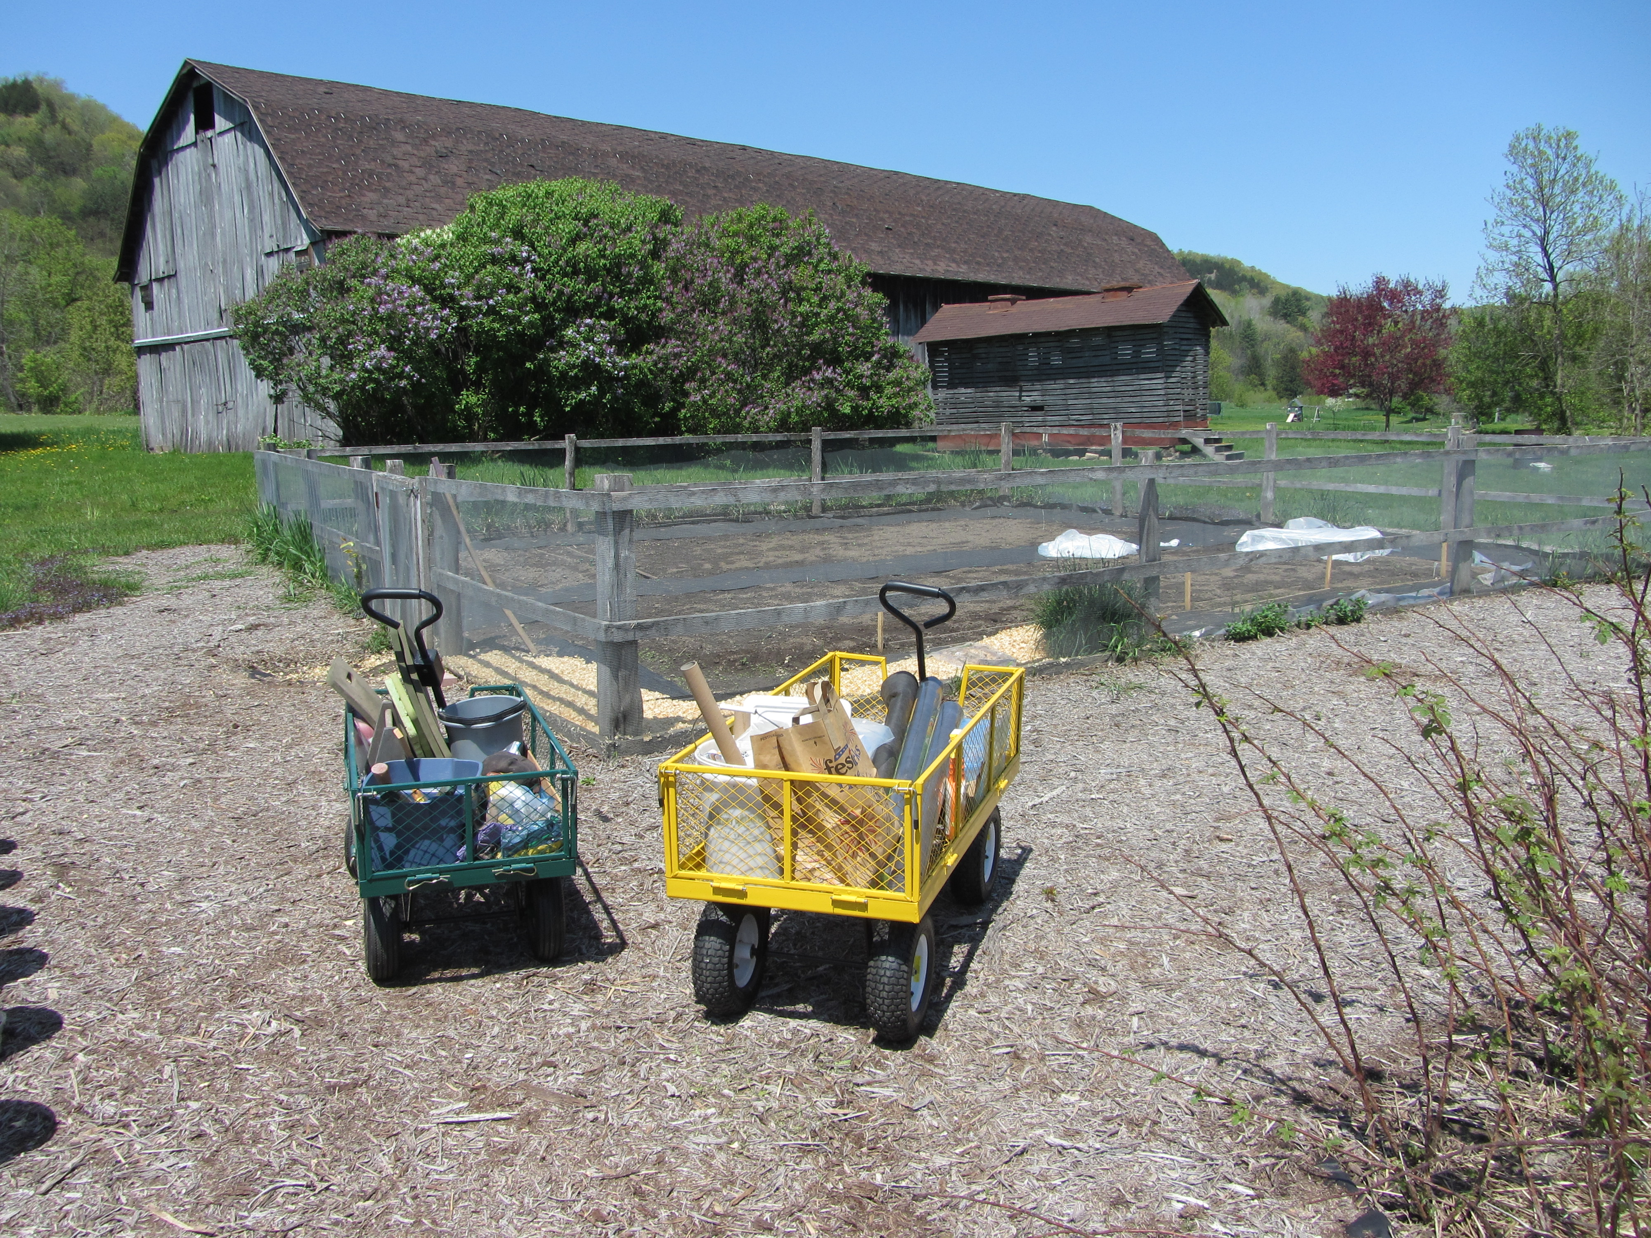

Seedtime . . . And Harvest?

Water
Of
Life

13 May 2018

W A T E R O F L I F E

Independent Christian Church—Conservative Lutheran Doctrine

Worship Service: 9:30 a.m. Bible Study: 10:45 a.m.

Larry Cooper, Pastor E-Mail address:
111 N. Ridge Road lcooper@wateroflife.cc
Coon Valley, WI 54623 Web Site:
Phone: (608) 452-2105 www.wateroflife.cc

* * * * * * * * * * * * * * * * * * * * * * * * * * *

Sermon Text: Daniel 5:13-17

What Money Can’t Buy

* * * * * * * * * * * * * * * * * * * * * * * * * * *

Daniel 5:13 Then was Daniel brought in before the king. And the king spake and said unto Daniel, Art thou that Daniel, which art of the children of the captivity of Judah, whom the king my father brought out of Jewry?
:14 I have even heard of thee, that the spirit of the gods is in thee, and that light and understanding and excellent wisdom is found in thee.
:15 And now the wise men, the astrologers, have been brought in before me, that they should read this writing, and make known unto me the interpretation thereof: but they could not shew the interpretation of the thing:
:16 And I have heard of thee, that thou canst make interpretations, and dissolve doubts: now if thou canst read the writing, and make known to me the interpretation thereof, thou shalt be clothed with scarlet, and have a chain of gold about thy neck, and shalt be the third ruler in the kingdom.
:17 Then Daniel answered and said before the king, Let thy gifts be to thyself, and give thy rewards to another; yet I will read the writing unto the king, and make known to him the interpretation.



